**SQL Database Setup :**

Steps:

1.Back up file provided in the folder **TravelUp.bak** – copy to local machine and Please import this in SSMS

2.Open SSMS > Right click on Database > Restore Files and File groups

3. Select **From device** (refer screenshot) and give the .bak file path and click ok

4. This should successfully create **TravelUp** database in ur local machine

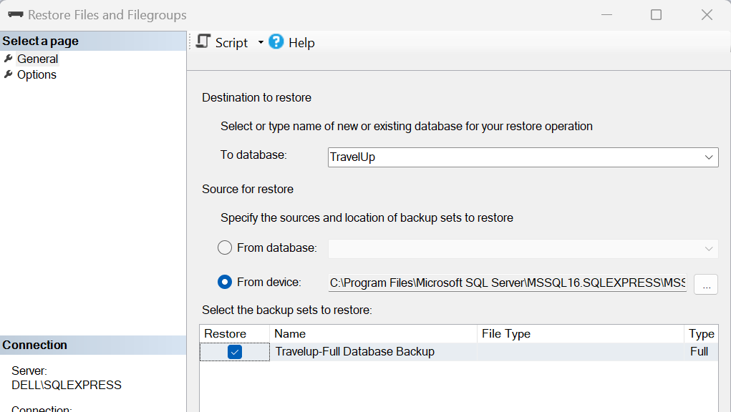

5. After import verify if the database contains 3 tables (refer screen shot) – Cities, passengers, segments

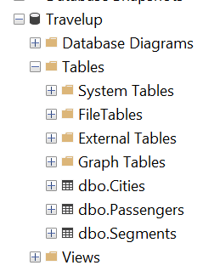

**Application code setup :**

1.Copy **TravelUp** folder to local computer and open the application using visual studio(VS)

2.Here we have 2 projects **TravelUp**(MVC) and **WebAPI** (API with .Net core)

3.Open 2 instances of visual studio as we need to run **webapi** project simultaneously with MVC application

4.In one VS instance make **WebAPI** as start project and other VS instance with **TravelUp** project as startup project

5. Build **WebAPI** project and then the **TravelUp** project (Travel up refers WebAPI)

**NOTE : Entity framework should be able to connect to TravelUp databse, make sure to use windows authentication for connecting with user name and password**

6. Run VS instance with **WebAPI** as start project and make sure swagger opens up successfully (screen shot for reference)

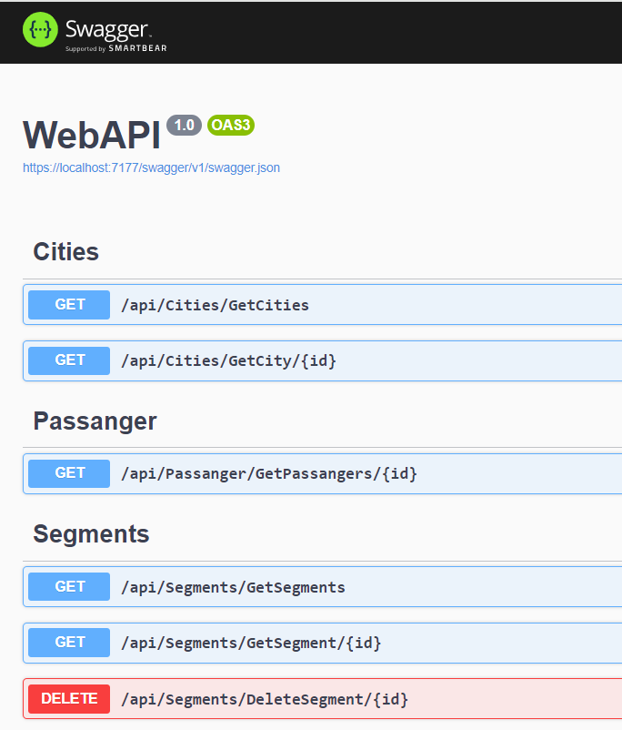

7. Reverify if WebAPI is running successfully by testing Get API using Swagger (screen shot for reference)

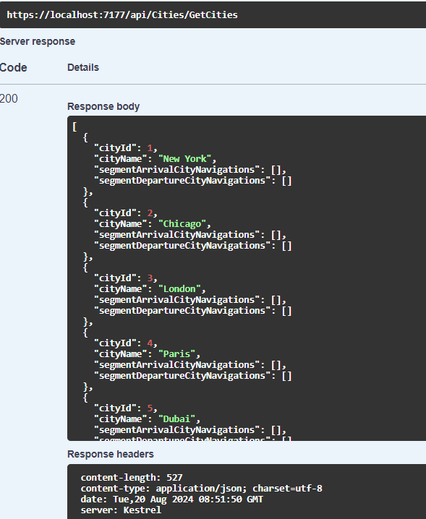

8. Now that the WebAPI project is up and running, Run the travel up project to see the home screen

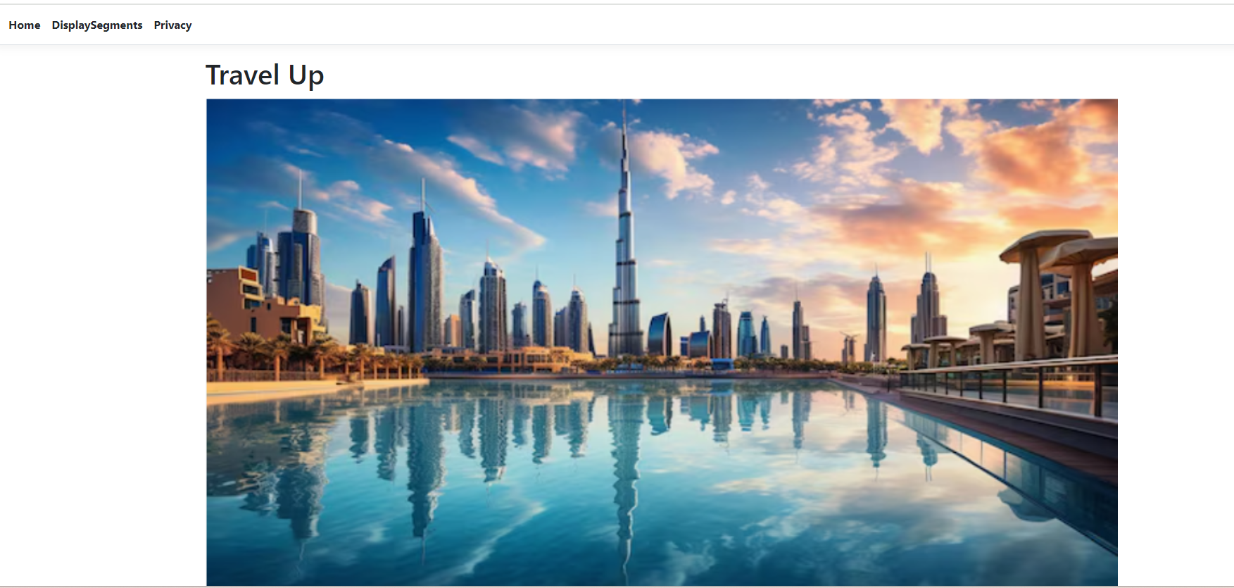

9. Click on the DisplaySegments in the header to view the segments, Edit, Delete and create

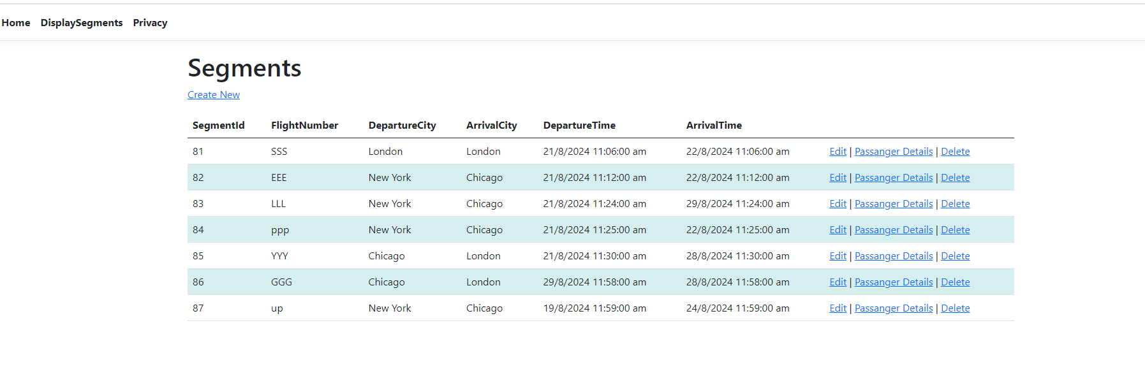

10. Test the application to create new segment, edit the existing segment, View the passengers for the existing segments and also delete the segment